**EX NO:2 SHELL PROGRAMMING**

**DATE:09.03.2021**

**Aim:**To write the following shell programs and execute in unix environment.

**Programs:**

**1.Write a shell program for getting and displaying academic details.Inputs are name,roll no,three marks of students and outputs are name,rollno,total and average.**

**Algorithm:**

**1.** Start

**2.** Create a file using vi command with filename.sh

**3.** Using ‘echo’ command, print “name,rollno,m1,m2 and m3 respectively”

**4**. Using ‘read’ command, read name,rollno,m1,m2,m3 from the user

**5.** Using ‘expr’ command,get the total marks by adding m1,m2,m3and average marks by dividing total marks by total no of marks i.e., 3

**6.** Using ‘echo’ command, print the student’s name,rollno,total marks and average to the user.

**7.** Stop.

Program:

read name

echo "rollno"

read rollno

echo "m1"

read m1

echo "m2"

read m2

echo "m3"

read m3

echo $name

echo $rollno

echo $m1

echo $m2

echo $m3

total=`expr $m1 + $m2 + $m3`

echo $total

average=`expr $total / 3`

echo $average

echo "name"

read name

echo $name

echo "rollno"

read rollno

echo $rollno

echo "m1"

read m1

echo $m1

echo "m2"

read m2

echo $m2

echo "m3"

read m3

echo $m3

total=`expr $m1 + $m2 + $m3`

echo $total

average=`expr $total / 3`

echo $average

**Output:**

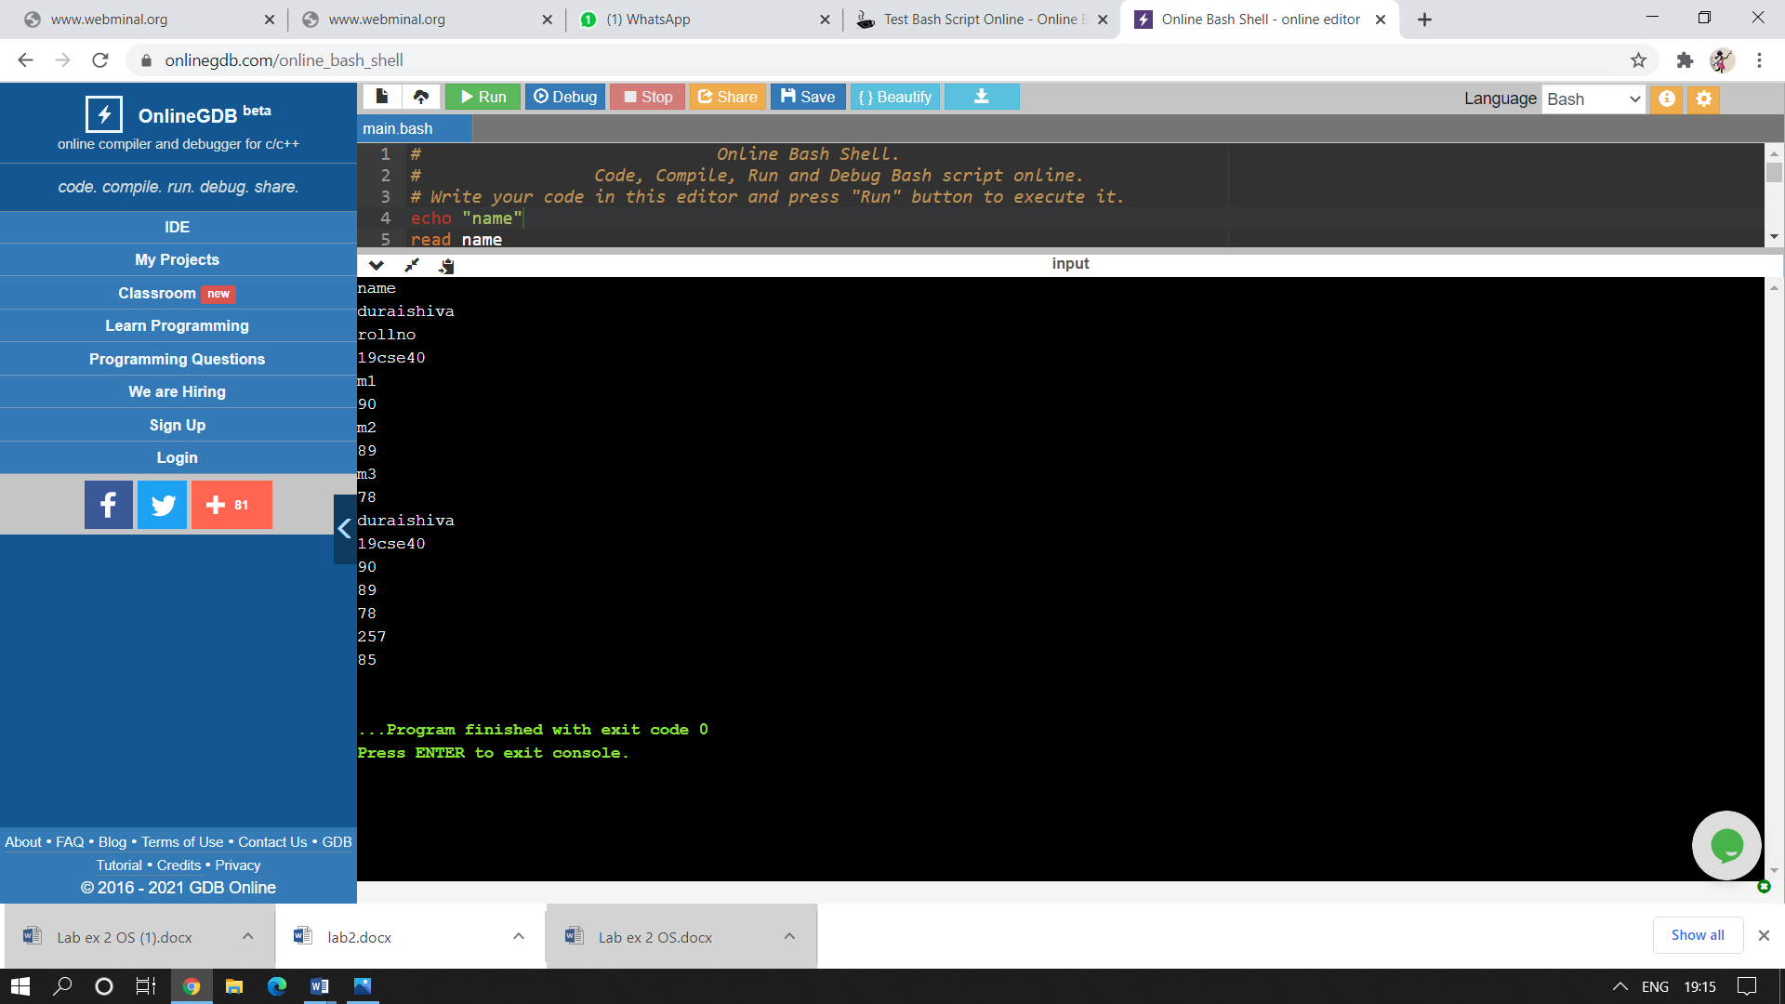

**2.Write a shell program to implement the arithmetic operations.**

**Algorithm:**

**1.** Start

**2.** Create a file using vi command with filename.sh

**3**. Using ‘read’ command, read the value of a and b from the user

**4.** Using ‘expr’ command,perform the arithmetic operations such as add, subtract,multiplyand divide with a and b.

**5.** Using ‘echo’ command, print the addition,subtraction,multiplication,division results to the user.

**6.** Stop.

**Program:**

read a

read b

add=`expr $a + $b `

sub=`expr $a - $b `

mul=`expr $a \* $b `

div=`expr $a / $b `

echo “ $add”

echo “$sub”

echo “$mul”

echo “$div”

**Output:**

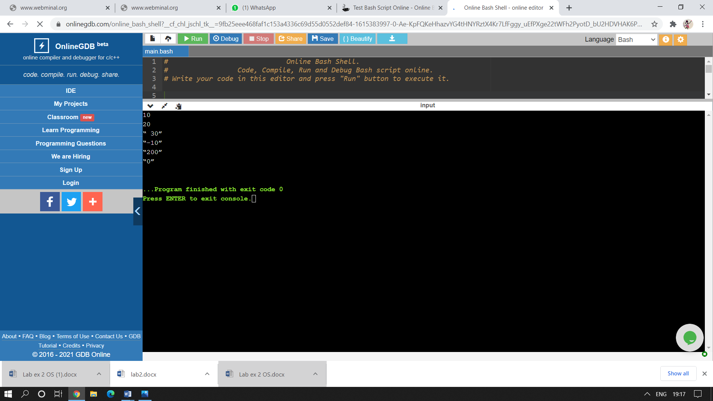

**3.Write a shell program to check whether the given number is positive,negative and zero.**

**Algorithm:**

**1.** Start

**2.** Create a file using vi command with filename.sh

**3**. Using ‘read’ command, read the value of a from the user

**4.** Using ‘if’ loop ,check the conditions greater than zero for positive,less than for negative and zero.

**5.** Using ‘echo’ command, print whether the value is positive,negative or zero.

**6.** End the ‘if’ loop using fi.

**7.**Stop.

**Program:**

read a

if [ $a –gt 0 ]

then

echo “ $a is positive”

elif [ $a –lt 0 ]

then

echo “ $a is negative”

else

echo “$a is zero“

**Output:**



**4.Write a shell program to form combinations for 1 2 3.**

**Algorithm:**

**1.** Start

**2.** Create a file using vi command with filename.sh

**3.** Using three ‘for’ loops ,specify the values for a,b and c in 1,2,3.

**4.** Using ‘echo’ command, printthe values as combinations of the three numbers i.e 111 112 etc..,.

**5.** End the ‘for’ loops using done.

**6.**Stop.

**Program:**

for a in 1 2 3

do

for b in 1 2 3

do

for c in 1 2 3

do

echo “ $a $b $c”

done

done

done

**Output:**

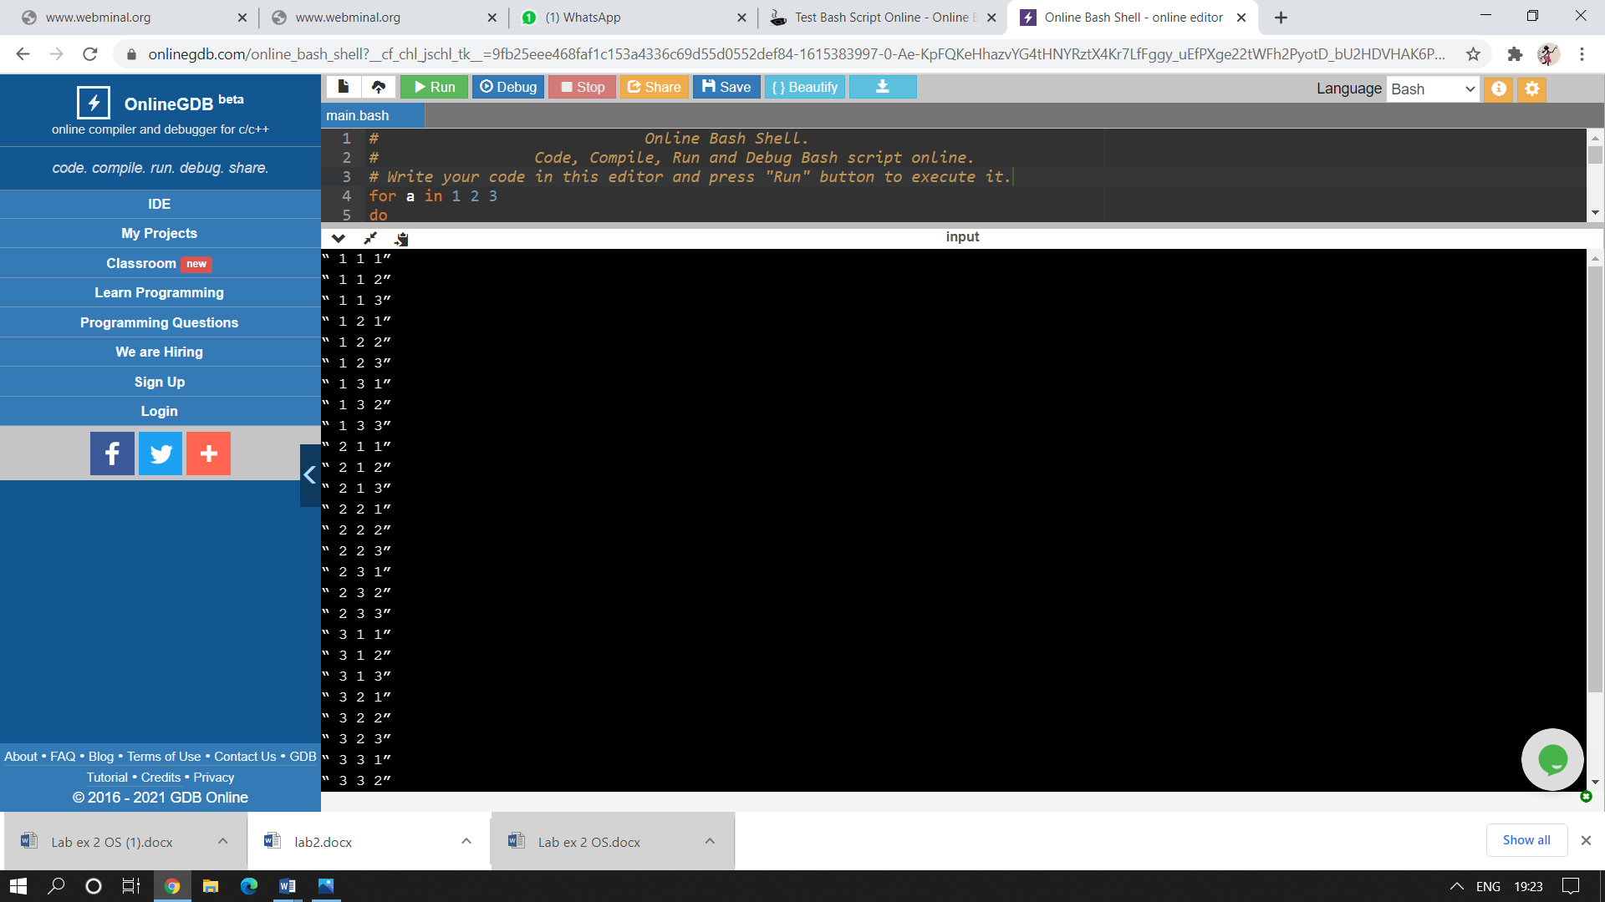

**5.Write a shell program to find the area of triangle,circle,square and rectangle using switchcase.**

**Algorithm:**

**1.** Start

**2.** Create a file using vi command with filename.sh

**3.** Using ‘switch case’ , evaluate the area of triangle,circle,square and rectangle.

**4.** Using ‘echo’ command, print “enter a value between 1 and 4”.

**5.** Using the ‘read’command,get ‘a’ value.

**6.**Inside the switch case write commands for the areas of triangle,circle,square and rectangle.

**7.**End ‘case’ using ‘esac’.

**8.**Stop.

**Program:**

echo “ enter a value between 1 and 4”

read a

case $a in

1)echo “area of triangle”

read b

read h

triangle=`expr $b \* $h \* 1 / 2`

echo “$triangle”

;;

2)echo “area of circle”

read r

circle=`expr $r \* $r \* 22 / 7`

echo “$circle”

;;

3)echo “area of square”

read c

square=`expr $c \* $c`

echo “$square”

;;

4)echo “area of rectangle”

read l

read b

rectangle=`expr $l \* $b`

echo “$rectangle”

;;

esac

**Output:**

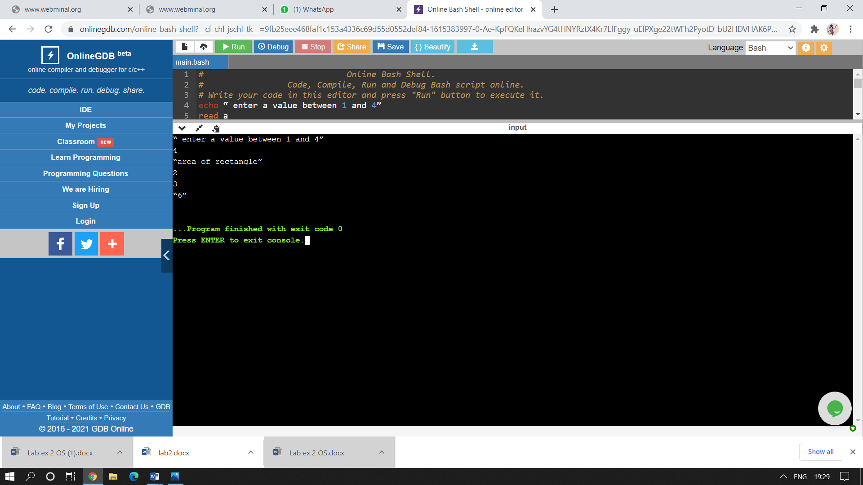

**6.Write a program to concatenate two strings and find the length of the resultant string.**

**Algorithm:**

1.Start

2.Create a file using vi command with filename.sh

3.Using ‘read’ command ,read two strings.

4.Concatenate two strings and store it in c.

5.Find the length of c by the code ${#c}

6.Using ‘echo’ command,display the result to the user.

7.End

**Program:**

read a

read b

c=”${a}${b}”

echo “resultant string is $c”

echo “the length is ${#c}”

**Output:**

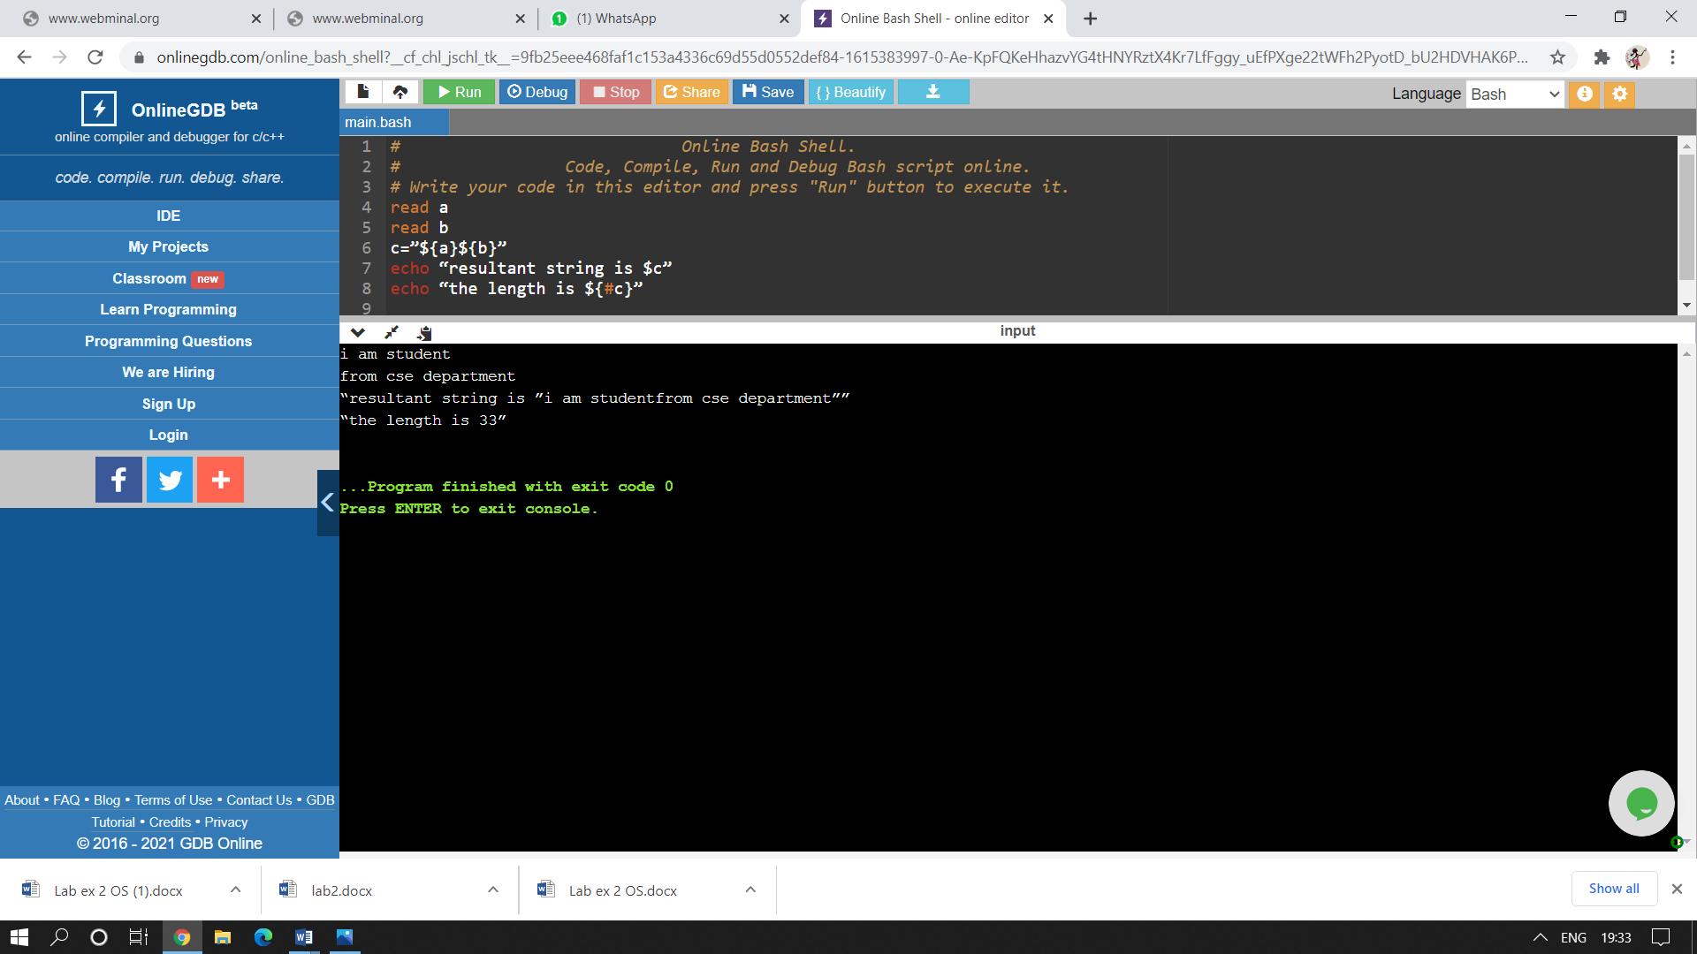

**7.Write a program to display the digits which are in odd position in the given number.**

**Algorithm:**

1.Start

2.Create a file using vi command with filename.sh

3.Using ‘read’ command, read n value

4.Initialize count =1 and find the length of the number entered by the user

5.Using ‘while’ and ‘check’ ,if count is less than or equal to length if yes,cut the number in that position and display it using echo and increment count by 2

6.Do it until the count is less than or equal to length of the input number

7.End

**Program:**

read n

count=1

len=${#n}

while [ $count –le $len ]

do

a=`echo $n | cut –c $count

echo “$a”

count=` expr $count +2 `

done

**Output:**

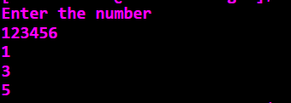

**8.Write a program to search an element in an array.**

**Algorithm:**

**1.** Start

**2.** Create a file using vi command with filename.sh

**3.**Initialize the array elements and initialise it to the user.

**4.**Using ‘read’ command , get the number to be searched and then set the flag as 0.

**5.**Use a ‘for’ loop and set conditional position as 0 and use ‘if’ loop inside it and check whether the position of the current number is equal to the position of the number entered,if yes change flag value to 1 orelse flag remains 0.

**6.** Increment the position.

**7.**Display the result.

**8.**Stop.

**Program:**

a=(1 2 3 4 5)

echo “array elements are ${a[@]}”

echo ”enter number to be searched “

read n

flag=0

for i in “${a[@]}”

do

if [ $i -eq $n ]

then

flag=1

fi

done

if [ $flag -eq1 ]

then

echo “found”

else

echo “not found”

fi

**Output:**

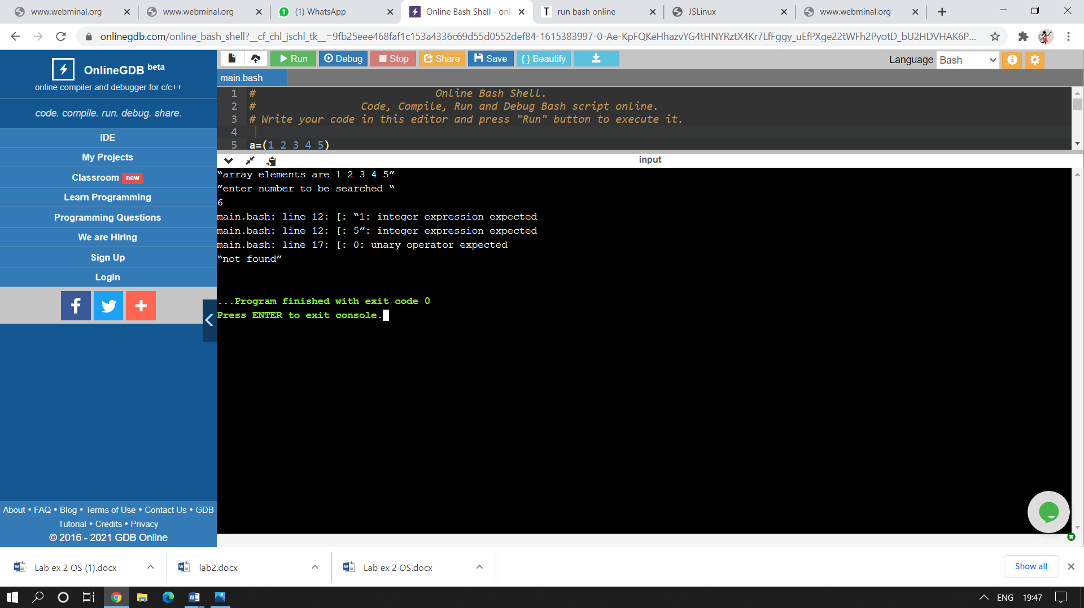

**9.Write a program to delete the zero sized file using if and for.**

**Algorithm:**

**1.** Start

**2.** Create a file using vi command with filename.sh

**3.**Using ‘echo’ and ‘read’ command , get the filename from the user.

**4.**Using ‘if’ loop,check whether the file exists or has filesize greater then 0 orelse file is deleted using ‘rm’ command.

**5.** Displays file not exists,otherwise.

**6.**Stop.

**Program:**

echo “enter filename”

read fn

if [ -e $fn ]

then

echo “file exists”

if [ -s $fn ]

then

echo “filesize > 0”

else

echo “empty file deleted”

rm $fn

fi

else

echo “file not exists”

fi

**Output:**

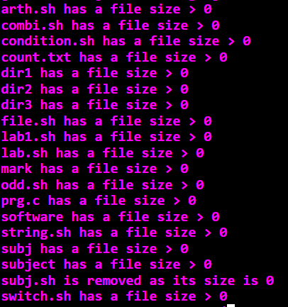

**10.Write a program to reverse a number.**

**Algorithm:**

**1.** Start

**2.** Create a file using vi command with filename.sh

**3.**Using ‘read’ command , get the a value from the user and assume r and re values as 0 and null respectively.

**4.**Using ‘while’ loop,check if a value is not equal to zero,then perform modulus and division operations,to get the reversed number.

**5.** Displays reversed number.

**6.**Stop.

**Program:**

read a

r=0

re=””

while [ $a ne 0 ]

do

r=`expr $a % 10`

a=`expr $a / 10’

re=”${re}${r}”

done

echo “reversed number is ${re}”

**Output:**

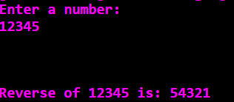

|  |  |
| --- | --- |
| **Observation(20)** |  |
| **Record(5)** |  |
| **Total(25)** |  |
| **Initial** |  |

**Result:**

Thus the shell commands were executed and outputs were noted.